Tugas Sistem Terdistribusi



**Disusun Oleh :**

**Nama : Dewi Purnama**

**NIM : 09011182126020**

**Jurusan : Sistem Komputer**

**Dosen : Adi Hermansyah, M.T.**

Jurusan Sistem Komputer

Fakultas Ilmu Komputer

Universitas Sriwijaya

2024

DNS (nslookup, dig, nmap)

1. nslookup
2. nslookup google.com

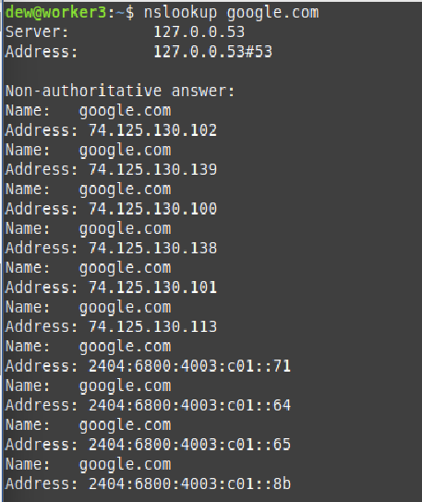

1. nslookup facebook.com

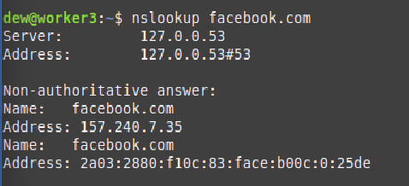

1. nslookup twitter.com

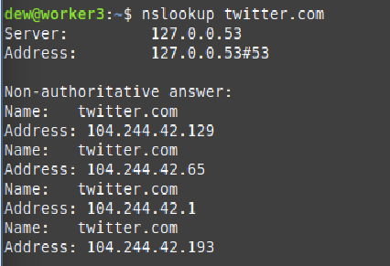

1. nslookup amazon.com

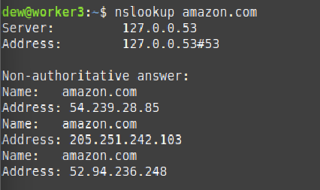

1. nslookup microsoft.com

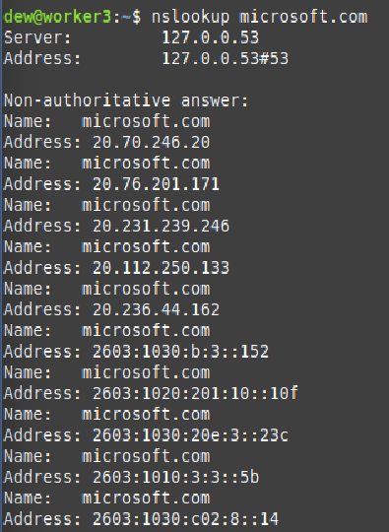

1. nslookup instagram.com

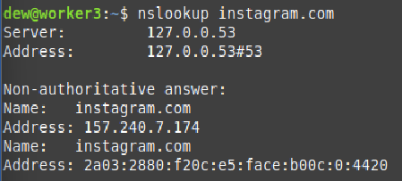

1. nslookup youtube.com

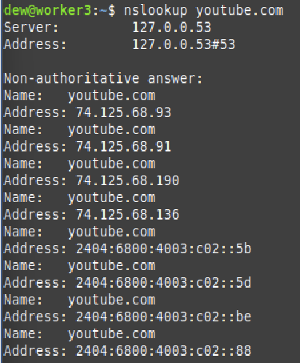

1. nslookup linkedin.com

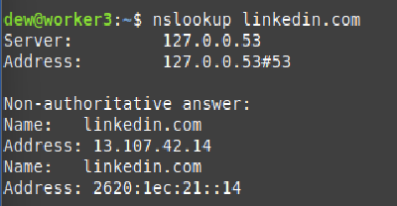

1. nslookup wikipedia.com

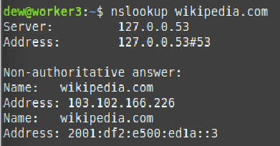

1. nslookup apple.com

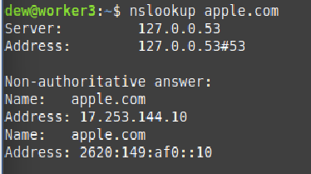

1. dig
2. dig google.com +short

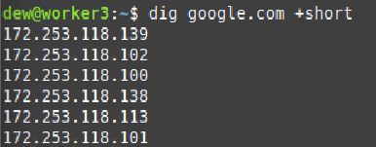

1. dig facebook.com +short



1. dig twitter.com +short



1. dig amazon.com +short

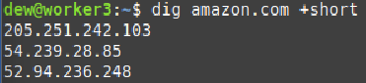

1. dig microsoft.com +short

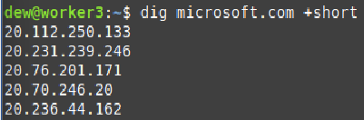

1. dig instagram.com +short



1. dig youtube.com +short

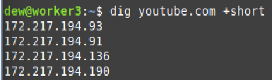

1. dig linkedin.com +short



1. dig wikipedia.org +short



1. dig apple.com +short



1. nmap
2. nmap -p 1-65535 172.217.19.46

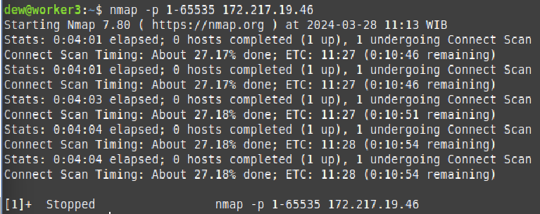

1. nmap -p 1-65535 157.240.20.35

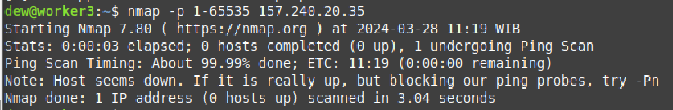

1. nmap -p 1-65535 104.244.42.65

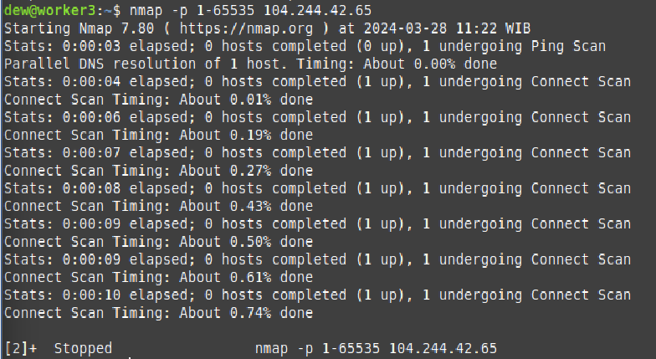

1. nmap -p 1-65535 176.32.98.166

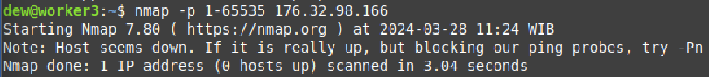

1. nmap -p 1-65535 13.77.161.179

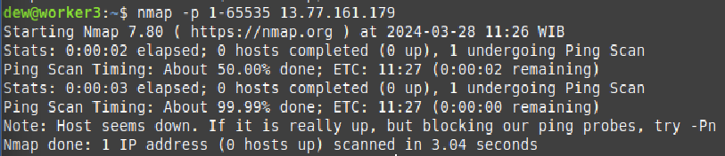

1. nmap -p 1-65535 157.240.7.174

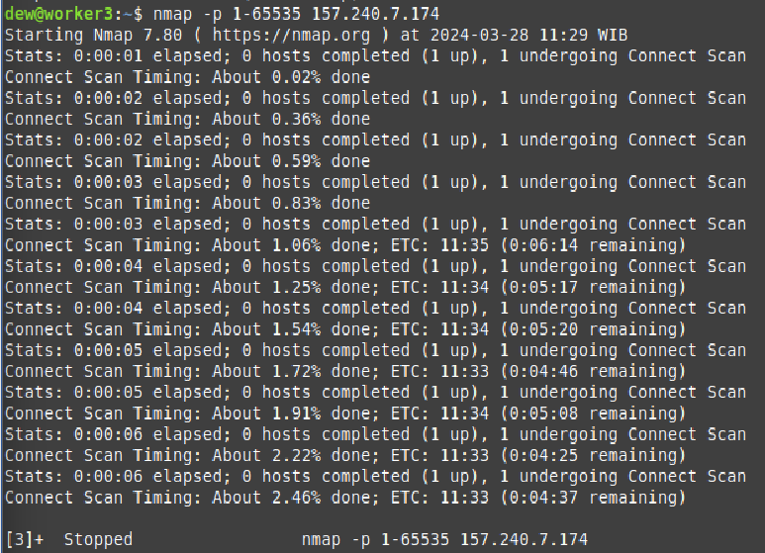

1. nmap -p 1-65535 172.217.194.93

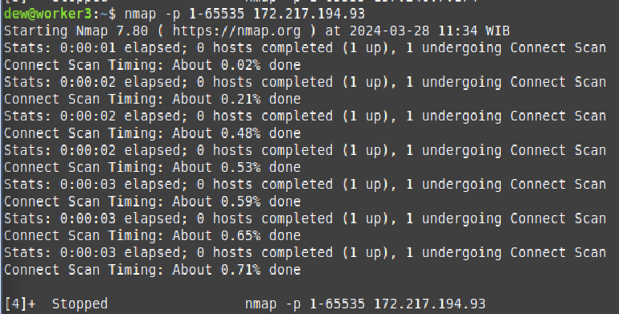

1. nmap -p 1-65535 13.107.42.14

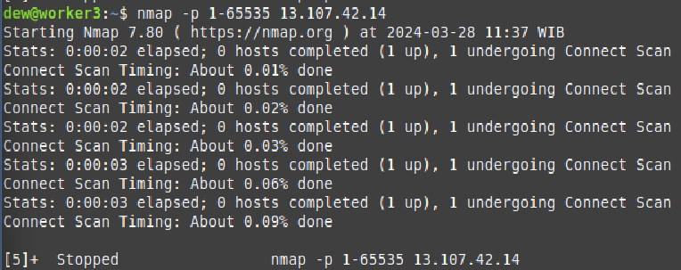

1. nmap -p 1-65535 103.102.166.226

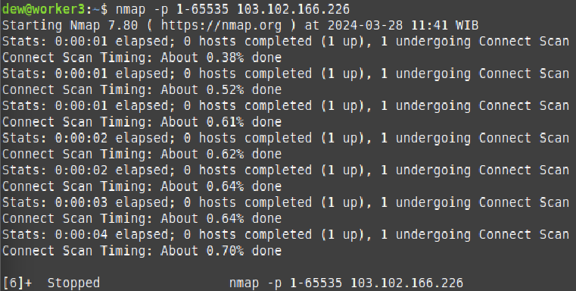

1. nmap -p 1-65535 17.253.144.10

